Model Development Phase Template

|  |  |
| --- | --- |
| Date | 15 March 2024 |
| Team ID | 739927 |
| Project Title | Smart Lender- Flight delay prediction |
| Maximum Marks | 4 Marks |

**Initial Model Training Code , Mode lV a lidation and Evaluation Report**

The initial model training code will be showcased in the future through a screenshot.The model validation and evaluation report will include classification reports, accuracy, and confusion

matrices for multiple models, presented through respective screenshots.

**Initial Model Training Code:**

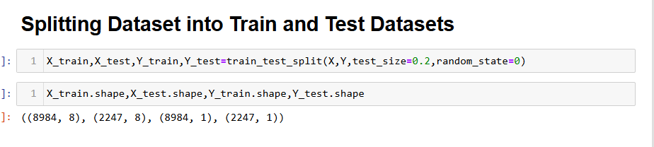



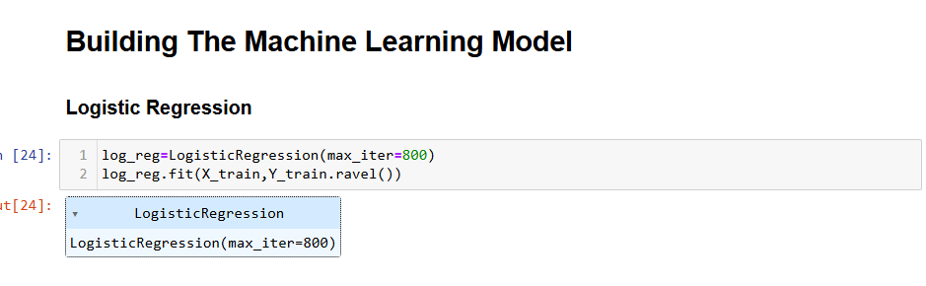

**Mode lV alidation and Evaluation Report:**

|  |  |  |  |
| --- | --- | --- | --- |
| **Model** | **Classification Report** | **F1**  **Scor e** | **Confusion Matrix** |
| Random Forest | C:\Users\DELL\Desktop\matr.PNG | 92% | C:\Users\DELL\Desktop\conf.PNG |
| **Logistic Regression** | **C:\Users\DELL\Desktop\building.PNG** | **-** | **C:\Users\DELL\Desktop\conf.PNG** |